RESEARCH METHODOLOGY AND BASELINE RESULTS
Domain-Aware Group-Structured Pruning of YOLO26n
General Traffic and Snow-Condition Object Detection
18 July 2026
Status: the GEN and SNOW software baselines are complete. Dependency-group construction, isolated pruning measurements and cumulative pruning remain pending.

Executive Summary
This study investigates structured pruning of YOLO26n for general traffic detection and snow-condition detection. The original software baselines are now complete on MIO-TCD (GEN) and the ACDC snow subset (SNOW). The next stage will prune the same dependency-safe channel group on both domains and record the resulting accuracy changes.
The proposed contribution is the combination of a current lightweight detector, dependency-aware structural pruning and signed cross-domain sensitivity analysis for low-visibility conditions. The sensitivity equation is defined in this report. No prunability equation is proposed yet; Rafed will work with the software intern to finalize it before cumulative pruning and ranking begin.
Scope. This phase evaluates software accuracy and model efficiency. FPGA deployment is a later phase and is not claimed in the present report.

1. Completed Software Baselines
The two baselines were trained and evaluated independently because the datasets have different classes, sizes and difficulty. Their absolute mAP values are therefore not a direct fairness comparison. They provide the reference values required to measure each domain's response to the same pruning intervention.
Table 1. GEN baseline: MIO-TCD and YOLO26n
Category | Item | Verified result
Dataset | Split | 88,000 train; 11,000 validation; 11,000 held-out internal test
Dataset | Classes | 11 traffic-object classes
Training | Configuration | Seed 42; 640 px; batch 16; maximum 100 epochs; patience 20
Training | Completion | 93 epochs completed; best epoch 73; 131,735 optimizer updates
Training | Final losses | Box 0.97553; classification 0.51003; DFL 0.00384
Validation | mAP50-95 / mAP50 / AP75 | 0.64715 / 0.83097 / 0.72472
Validation | Precision / recall / macro F1 | 0.79793 / 0.77947 / 0.78178
Validation | Images / objects | 11,000 / 29,481
Model | Parameters / GFLOPs / checkpoint | 2,508,090 / 5.7933 / 5,385,470 bytes
Latency | FP32 core / pipeline median | 6.403 ms / 9.637 ms (RTX 4060, batch 1, 640 px)
Audit | Independent COCO AP50-95 | 0.63982; five zero-area exports excluded only from COCOeval
Table description. The GEN model provides the general-domain reference M_GEN,0. The internal test split remains held out; the reported accuracy is from the validation split. Latency excludes disk input/output and is hardware-specific.
Table 2. SNOW baseline: ACDC snow and YOLO26n
Category | Item | Verified result
Dataset | Split | 400 train; 100 validation; 500 official test images
Dataset | Classes | 8 detection classes; official test labels withheld
Training | Configuration | Seed 42; 640 px; batch 16; maximum 100 epochs; patience 20
Training | Completion | Early stopping after 64 epochs; best epoch 44; 420 optimizer updates
Training | Final losses | Box 1.60742; classification 1.18635; DFL 0.00285
Validation | mAP50-95 / mAP50 / AP75 | 0.19198 / 0.32626 / 0.18561
Validation | Precision / recall / macro F1 | 0.57334 / 0.25306 / 0.30635
Validation | Images / objects | 100 / 818
Model | Parameters / GFLOPs / checkpoint | 2,506,920 / 5.7868 / 5,374,078 bytes
Latency | FP32 core / pipeline median | 16.827 ms / 23.663 ms (RTX 4060, batch 1, 640 px)
Audit | Independent COCO AP50-95 | 0.19550; recovered run passed finite-history and checkpoint audits
Table description. The SNOW model provides the snow-domain reference M_SNOW,0. Lower accuracy is expected because this subset is small and visually difficult. The official test annotations are unavailable, so the reported accuracy is from validation data.

2. Proposed Framework
The supervisor's proposed structure is retained. A 'layer' in the experimental tables will mean a root pruning operation together with every connected channel operation that must change for the model graph to remain valid.
- Evaluate and freeze the unpruned GEN and SNOW reference models.
- Use DepGraph to generate structurally valid pruning groups, followed by a manual audit of residual, concatenation and Detect-head connections.
- Apply the same pruning fraction to one legal group at a time and evaluate the immediate accuracy change on GEN and SNOW.
- Record the GEN results in T1, SNOW results in T2, and normalized cross-domain sensitivity in T3.
- After the prunability definition is frozen, rank groups and prune cumulatively until the selected model-size target is met.
- Fine-tune the selected model and report accuracy, model size, computation, latency and ablation results in T4.
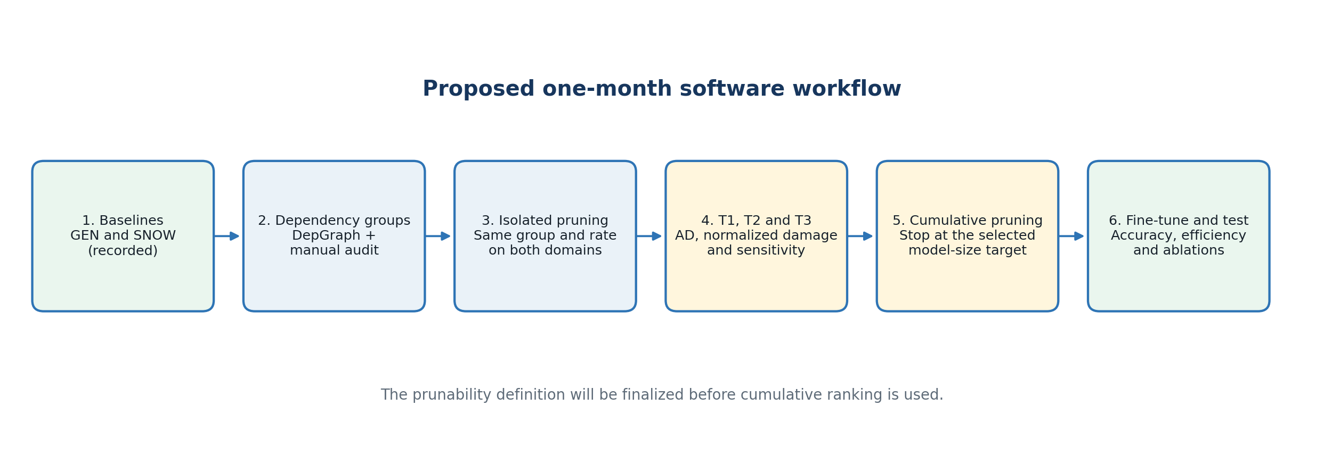
Figure 1. Proposed one-month software workflow.
Figure description. The workflow preserves the supervisor's GEN-SNOW-T1-T3 structure. Dependency grouping makes each pruning intervention executable, while the final ranking definition is deliberately left open for joint refinement.

3. Literature Review
Table 3. Main lessons from the five reviewed papers
Paper | Method used | Lesson retained for this study
Lian et al. (2024) | Cross-layer importance from sampled accuracy responses | Layer allocation should use comparable responses across the network, not only within-layer filter magnitude.
Li et al. (2017) | L1-norm structured filter pruning and layer sensitivity tests | Whole-filter removal gives a physically smaller dense model; L1 pruning is a necessary baseline.
Jeon et al. (2023) | Single-shot channel pruning with layer-wise sensitivity and resource constraints | A ranking should consider both sensitivity and the intended resource boundary.
Wang et al. (2025) | Sensitivity-guided dynamic pruning for test-time adaptive detection | Removing a channel may help or harm a domain; signed effects must be preserved.
Fang et al. (2023) | Dependency Graph for arbitrary structural pruning | A valid pruning unit is a dependency group, not an isolated layer in a connected detector.
Table description. The papers support the individual building blocks of the method. They do not, by themselves, establish the proposed combined GEN-versus-SNOW analysis on YOLO26n.
Table 4. Research gaps and targeted uniqueness
Paper | Gap relative to this study | How this work targets uniqueness
Lian et al. (2024) | Classification-focused cross-layer allocation; no matched adverse-weather detector analysis. | Measure the same legal YOLO26n group on GEN and real-snow detection using normalized, signed accuracy changes.
Li et al. (2017) | Single-domain magnitude pruning; limited treatment of modern detector graph dependencies. | Use L1 pruning as a baseline, then compare it with dependency-safe, snow-aware group ranking and exact dense-model savings.
Jeon et al. (2023) | Sensitivity is estimated mainly at initialization and not from observed snow-domain detection damage. | Use measured post-intervention validation mAP changes in two domains and relate ranking to the final size boundary.
Wang et al. (2025) | Dynamic test-time adaptation on Faster R-CNN, rather than offline static compression of YOLO26n. | Study a static, deployable YOLO26n model and explicitly separate GEN-sensitive from SNOW-sensitive groups.
Fang et al. (2023) | Solves structural dependencies but does not define domain importance for adverse-weather detection. | Combine DepGraph's legal groups with task evidence from GEN and SNOW, then validate cumulative pruning and recovery.
Table description. The intended novelty is the complete framework: current lightweight YOLO26n, real-snow domain evidence, dependency-safe structured pruning, signed normalized sensitivity, and stopping at a constrained model-size target. Final novelty claims will depend on the ablation and cumulative-pruning evidence.

4. Dependency-Safe Pruning Groups
DepGraph will trace the model once and return the channel operations that must be pruned together. This avoids manually discovering every dependency. Manual work is still needed to verify each proposed group, exclude unsafe output layers, and label groups clearly for T1-T3.
Table 5. Important YOLO26n structural cases
Structure | Why isolated pruning fails | Planned treatment
Sequential convolution | Removing an output channel changes the next layer's input width. | Prune the root output and matching downstream input channel together.
Residual addition | Both tensors entering addition must keep compatible channel shapes. | Group coupled branches or reject the root if a valid group cannot be formed.
Concatenation | Downstream channel indices shift when one branch loses channels. | Propagate the removed indices through concatenation into consumers.
Detection head | Final prediction dimensions encode fixed task outputs. | Prune eligible internal features only; protect final prediction outputs.
Table description. These rules convert the supervisor's layer-level experiment into a physically valid group-structured experiment without changing its overall logic.

5. Signed, Normalized Sensitivity
Let M_GEN,0 and M_SNOW,0 be the unpruned validation metric, and let M_GEN,i and M_SNOW,i be the metric after pruning group i by the fixed probe fraction. Accuracy damage is retained as a signed value: a negative value means pruning improved the measured metric.
AD1_i = M_GEN,0 - M_GEN,i
Raw accuracy change for the GEN domain.
AD2_i = M_SNOW,0 - M_SNOW,i
Raw accuracy change for the SNOW domain.
D_GEN,i = AD1_i / M_GEN,0 and D_SNOW,i = AD2_i / M_SNOW,0
Baseline-normalized damage makes the two domains comparable despite different starting mAP values.
S_i = (D_GEN,i - D_SNOW,i) / max(|D_GEN,i|, |D_SNOW,i|, epsilon_S)
Signed relative disagreement between the two domains; epsilon_S is a small predeclared numerical floor.
Table 6. Interpretation of the sensitivity value
Sensitivity result | Meaning | Pruning implication
S_i < 0 | SNOW suffers more normalized damage than GEN. | Treat the group as snow-sensitive and apply additional caution.
S_i > 0 | GEN suffers more normalized damage than SNOW. | The trade-off is mainly against general-domain performance.
S_i near 0 | The two normalized responses are similar. | Inspect their magnitudes: both may be safe, or both may be severely damaged.
Table description. The sign identifies which domain is relatively more affected. Sensitivity alone is not a safety score, so T3 will retain the raw and normalized damage values beside S_i.
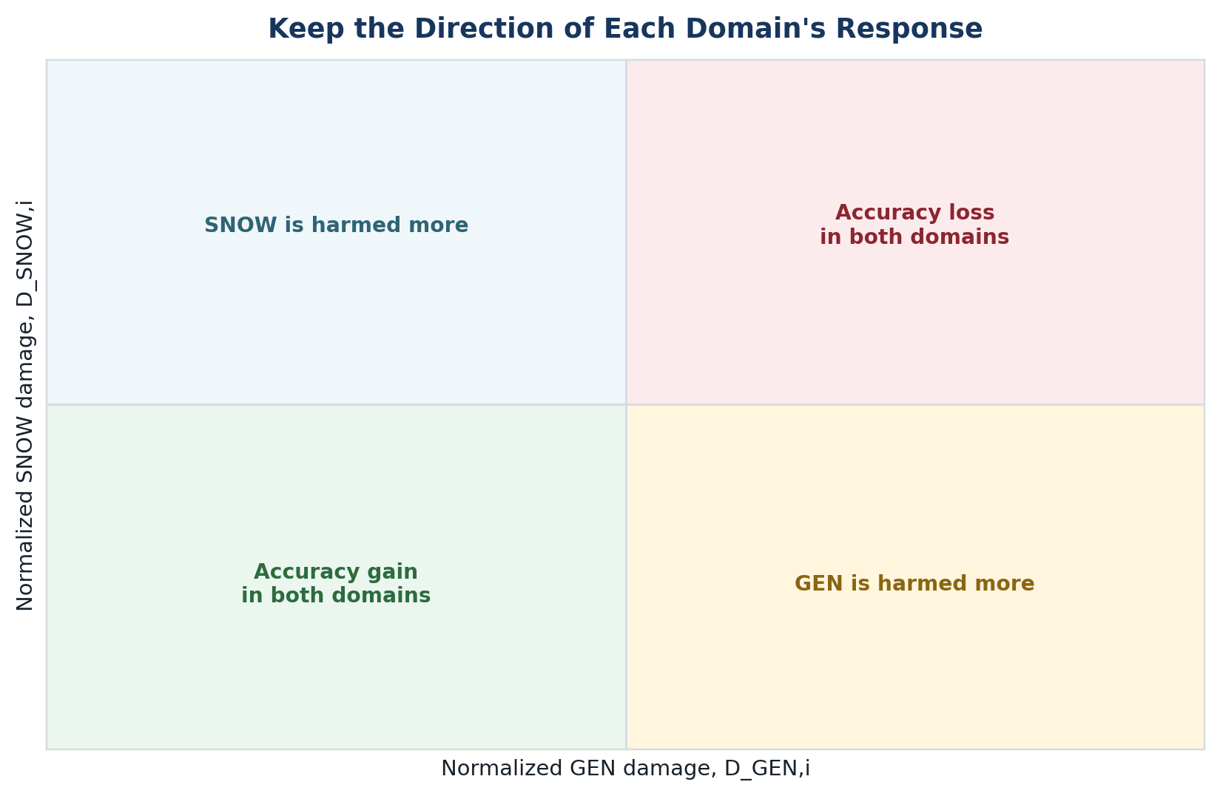
Figure 2. Direction of the two normalized accuracy changes.
Figure description. The sensitivity equation compares the domains, but the original two-dimensional response remains necessary. Equal damage in both domains can produce sensitivity near zero and must not be mistaken for a safe pruning group.
Table 7. Problems addressed by the revised sensitivity definition
Issue | Adopted treatment | Benefit
Different baseline mAP | Normalize each accuracy change by its own unpruned baseline. | A fixed raw loss is interpreted relative to the domain's starting performance.
Loss of direction | Do not apply an outer absolute value to the GEN-SNOW difference. | The sign shows which domain is more sensitive.
Pruning may improve accuracy | Keep AD and normalized damage signed. | Beneficial and harmful interventions are not treated as identical.
Unstable division near zero | Use the larger absolute normalized response with epsilon_S as a floor. | Bounds the scale and avoids division by zero.
Equal severe damage | Store AD1, AD2, D_GEN and D_SNOW with S_i in T3. | A near-zero disagreement cannot hide damage shared by both domains.
Table description. The revised equation is better suited to cross-domain comparison, while the accompanying columns prevent it from being over-interpreted as a complete pruning decision.
Prunability equation. No prunability formula is included in this report. I will work to finalize the definition, including how accuracy damage and physical model-size benefit should be combined. The equation and its constants will be documented and frozen before T3 is used for cumulative ranking.

6. Experimental Records and Validation
Table 8. Planned experiment tables
Table | Contents | Purpose
T1 | Group ID, root layer, dependency members, pruning fraction, GEN metric and AD1_i | Measure isolated GEN response.
T2 | Same group ID and pruning fraction, SNOW metric and AD2_i | Measure the matched isolated SNOW response.
T3 | AD1_i, AD2_i, D_GEN,i, D_SNOW,i, S_i, exact parameter/FLOP savings and later finalized rank | Compare domains and support the later pruning decision.
T4 | Cumulative groups, fine-tuning schedule, final metrics, size, GFLOPs and latency | Report the final accuracy-efficiency trade-off.
Table description. Every row will be traceable to the group definition, checkpoint, dataset split, random seed and evaluation output. The held-out test data will not be used for ranking decisions.
After a structural edit, BatchNorm running statistics may no longer match the changed activation distribution. Each candidate will therefore receive a fixed BatchNorm recalibration pass before the short post-pruning evaluation. This is not model retraining; it updates running mean and variance under a controlled calibration protocol. Final candidates will then be fine-tuned using the same declared recovery schedule.
- Use one fixed probe fraction, seed, image size and evaluation implementation for matched T1/T2 measurements.
- Record immediate damage, damage after BatchNorm recalibration, and recovered performance separately.
- Confirm that each saved model reloads, runs a forward pass and has physically reduced dense dimensions.
- Report parameters, GFLOPs and measured latency; do not infer real embedded latency from desktop GPU timing.
- Repeat the most important comparisons across multiple seeds or confidence intervals where the schedule permits.

7. Baselines and Ablation Studies
Table 9. Minimum comparisons needed for publication evidence
Comparison | Question answered
Random legal-group pruning | Does the proposed ranking outperform chance under the same pruning budget?
L1-magnitude structured pruning | Does domain-aware ranking improve on a standard structured-pruning baseline?
GEN-only and SNOW-only ranking | Is the cross-domain formulation useful beyond optimizing one dataset alone?
Raw AD versus normalized damage | Does normalization improve ranking stability when baseline mAP values differ?
With versus without signed sensitivity | Does preserving direction protect snow performance or reveal useful trade-offs?
Isolated versus cumulative pruning | Do interactions change the order predicted by one-group tests?
Before and after recovery | How much performance is restored by BatchNorm recalibration and fine-tuning?
Table description. These comparisons separate the value of dependency grouping, normalization, domain evidence and recovery. They are also necessary to support a defensible novelty claim.

8. One-Month Work Plan
Table 10. Four-week software plan
Week | Main focus | Clear target
Week 1 | Finalize sensitivity settings and prunability; build and audit dependency groups. | Frozen equations, legal group list and repeatable pruning procedure.
Week 2 | Run matched isolated group-pruning experiments on GEN and SNOW. | Completed T1 and T2 with validated artifacts.
Week 3 | Create T3, analyze rankings and prune cumulatively toward selected model-size targets. | Ranked groups and candidate compressed models.
Week 4 | Fine-tune, evaluate, run core ablations and organize publication evidence. | T4, comparison plots/tables and a defensible result summary.
Table description. The plan keeps targets broad because the number of legal pruning groups and training cost will only be known after the dependency audit. Accuracy and reproducibility take priority over completing an arbitrary number of runs.

9. Main Risks and Controls
Table 11. Main methodological risks
Risk | Control
GEN and SNOW have different classes and dataset sizes. | Compare normalized changes caused by the same intervention, not the absolute dataset scores.
The SNOW validation set is small. | Use fixed splits, repeat key runs, report uncertainty and avoid broad claims beyond real-snow ACDC evidence.
Automatic grouping may miss a model-specific constraint. | Audit residual, concatenation and detection-head paths, then test forward execution and output shapes.
Sensitivity near zero may hide shared severe damage. | Retain both raw and normalized domain damages in T3.
Isolated rankings may fail cumulatively. | Re-evaluate both domains after each cumulative step and allow stopping or reranking.
Novelty may be overstated. | Present novelty as a tested combination and support each claimed contribution with ablations.
Table description. These controls are part of the planned methodology. They do not imply that the risks have already been resolved experimentally.

10. Closing Summary
The project now has two reproducible software baselines. On the MIO-TCD validation set, YOLO26n reached mAP50-95 of 0.64715 and mAP50 of 0.83097. On the smaller ACDC snow validation set, it reached mAP50-95 of 0.19198 and mAP50 of 0.32626. These absolute scores should not be compared as if the datasets were identical; they are reference points for measuring how each domain changes after the same structured pruning action.
The reviewed literature supports structured filter removal, layer sensitivity, resource constraints, signed adverse-domain effects and dependency graphs. The remaining research gap is their controlled combination for a current lightweight YOLO26n detector using general traffic and real-snow evidence. The proposed sensitivity equation normalizes each accuracy change by its own baseline and preserves the sign of the domain difference. This allows the analysis to distinguish groups that are relatively more important to snow from those that are relatively more important to the general domain.
The immediate task is to construct and verify legal dependency groups, then complete the matched T1 and T2 experiments. I will work on finalizing the prunability definition before T3 is used for ranking. Cumulative pruning will then proceed toward a selected model-size boundary, followed by controlled recovery, final evaluation and ablation studies. Claims of novelty and publishability will be based on those measured comparisons; FPGA deployment remains outside the present software report.

References
Lian, Y., Peng, P., Jiang, K., & Xu, W. (2024). Cross-layer importance evaluation for neural network pruning. Neural Networks, 179, 106496.
Li, H., Kadav, A., Durdanovic, I., Samet, H., & Graf, H. P. (2017). Pruning filters for efficient ConvNets. ICLR.
Jeon, M., Kim, T., Lee, C., & Youn, C.-H. (2023). A channel pruning optimization with layer-wise sensitivity in a single-shot manner under computational constraints. IEEE Access, 11, 7043-7055.
Wang, K., Fu, X., Lu, X., Ge, C., Cao, C., Zhai, W., & Zha, Z.-J. (2025). Efficient test-time adaptive object detection via sensitivity-guided pruning. CVPR, 10577-10586.
Fang, G., Ma, X., Song, M., Mi, M. B., & Wang, X. (2023). DepGraph: Towards any structural pruning. CVPR, 16091-16101.

